Lab 5 - Tables

Instructions
- Answer the below question in the boxes if needed.
- For coding exercises, code on your computer and zip all your code before submission.
- Please submit the assignment after you finish.

Part 1: Table Creation
Steps:

- Go to VS Code and open the folder that we created in Lab 1
- Create a new html file and name it as “table.html” inside the folder.
- Replace the HTML with the following code. (We have included some table styling for you already)

<!DOCTYPE html>
<html>
<head>
<title>Page Title</title>
<style>
table, th, td {
border:1px solid black;
}
</style>
</head>
<body>

</body>
</html>

- Build a table inside the body section so that it displays a table like the one below.

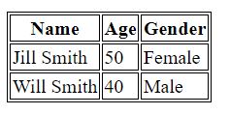

Part 2: Column Width

- The age column is too small. Set its width to 70 percent or more. Here is the sample output.

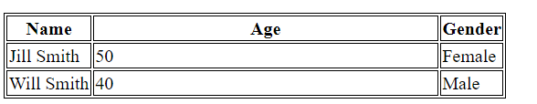

- Take a screenshot, name it as “part2”.

Part 3: Colspan

- We do not want separate headers for Age and Gender. We simply want a single header of “Properties” that spans two columns beside Name. We also want its width set to 70 percent. See the sample output.

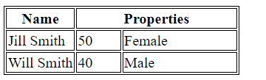

- Zip your final html file with the screenshot from part 2. Upload the zip file and submit it.

